**A description of the problem and a discussion of the background.**

The problem I try to answer is "what is the recommended location for a new cafe in New York". Suppose that a young entrepreneur, Jerry, wants to start his bussiness and he want to begin with a cafe. He is struggling with following questions: 1) Should I place my cafe in a place where there are a lot of existing cafes or in a place where there is none or should I try to find some kind of balance between these two extremes? 2) What is secret of a successful cafe? Can we get some tips or information based on the data provided by foursquare?

**A description of the data and how it will be used to solve the problem.**

For the problem one, I will: 1) find the high rating cafe in NY and identify them visually on a map; 2) create several "clusters" of these cafes to identfiy potential districts for Jerry to choose from. Jerry should choose one from these business district and locate his cafe in the center of it. The closer to the center, the high will be the rent. This is another choise that will be made by Jerry referring to his budget.

For the problem two, when Jerry has chosen a business district, researcher will collect the tips(customer reviews) for the cafe in that area and filter three types of tips - high ratings, low ratings and long comments because these tips will more likely include heeds for providing better services for the customers.

**Data for the research**

**1. Search for top-rated "cafe" in New York city and their locations**

We should use the "explore" endpoint. The request url is "<https://api.foursquare.com/v2/venues/explore>" According to the document, in the request, we should pass following parameters: "section=coffee" and "near=New York, NY". In the response, we are interested in groups.items.categories, groups.items.venue.name, group.items.venue.location. To simplify the problem, we will only use the geographic location to cluster the cafes.

**2. Find the tips**

We will recommend the "geographic mean"(the center of all cafes) as the location for Jerry. Based on this location, we use the search endpoint to get all the tips for coffee shops in the surrounding area (1km) . For this purpose, the Tips endpoint will be applied. The request url is "<https://api.foursquare.com/v2/venues/VENUE_ID/tips>" and VENUE_ID should be provided.

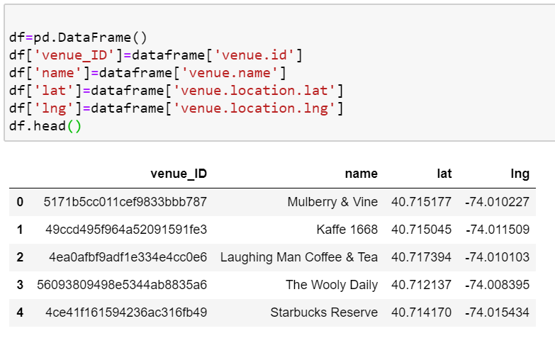

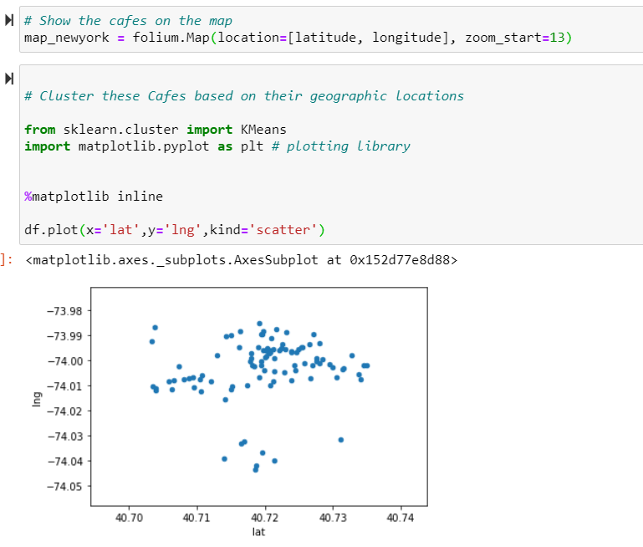

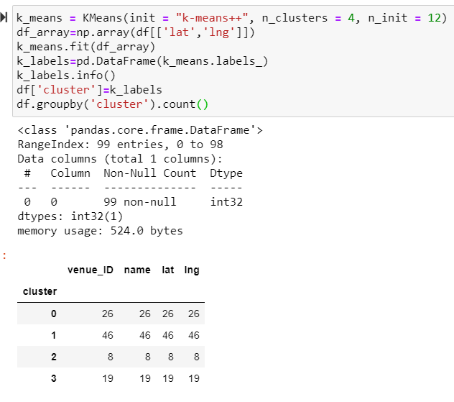

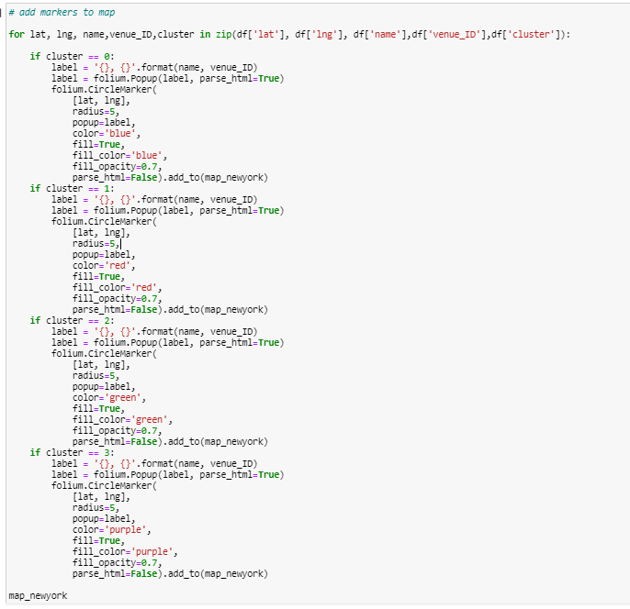

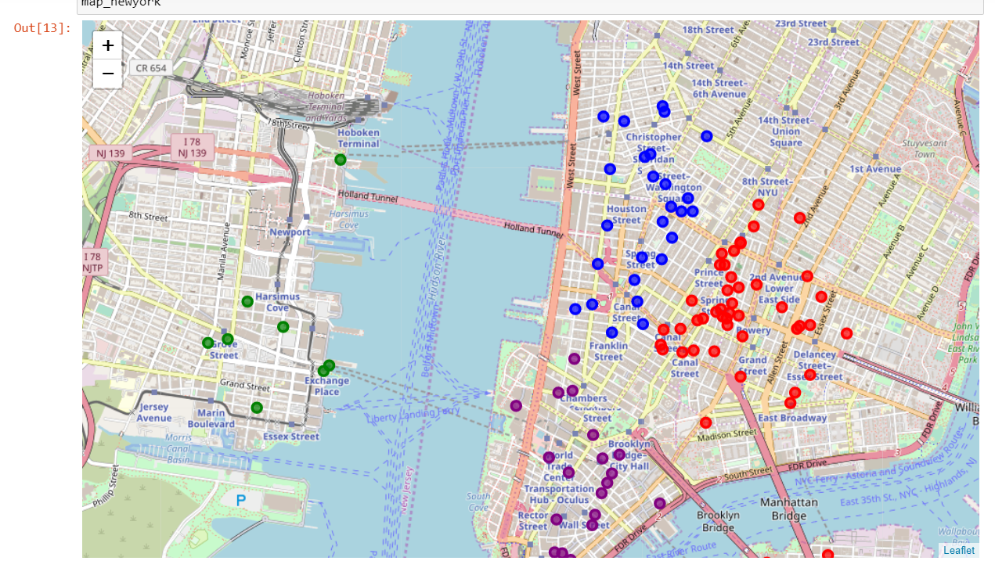

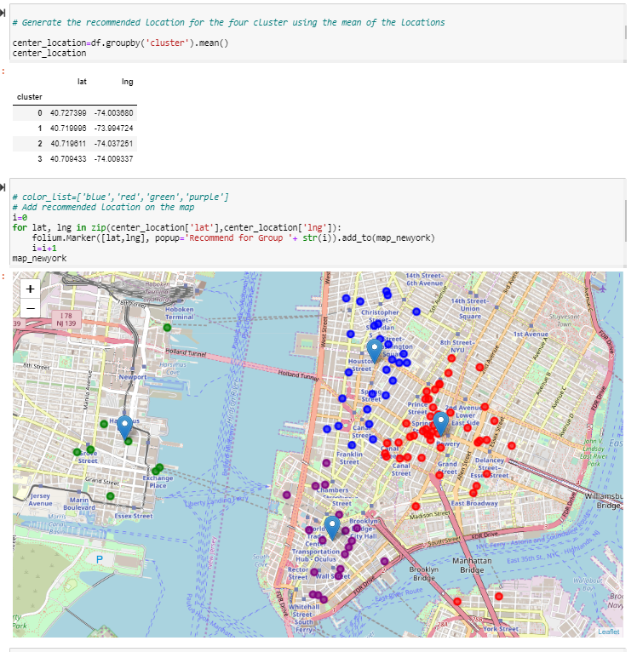

**Conclusion**

Jerry can select from the above shown area by seeing the customer tips of the cafes around this area. This graph and data will help Jerry to make a decision and start a successful business.